BOOK-COVER
Don´t judge a book by its cover is the english saying, but when it comes to books it becomes quite obvious that the cover is indeed important.
That´s why this weeks assignment will be to create your own book-cover. Front, back and spine. In order to create your cover you will use Photoshop. Before you create your cover you will need to create an alluring story to put on the back of your book so you can capture your ”byers” and have something to compete your frontside with.
Once you have finnished your story so it´s ready to go on the back you should start to design the front. It should be appealing and inviting so people will pick it up to read the backside but also the front should be an illustration connected to the events or characters in your story. And don´t forget the spine of your book, it´s at least as important as any other part of your book, the spine is the only thing you see once the book is standing in a shelf.
Now it´s time to start creating and the rest is up to you, it can be for example anything from a drama to horror or memoir.
You will decide what kind of book you want to create, for example, paperback, bound, cartonnage or audiobook. The thing that is important is that you choose the right measurements according to your kind of book. Think about your choice of type, how it affects your costumers in economical-, sustainabillity- and demand purposes.
After finished assignment you will present your book to your class. Following points should be in your presentation:
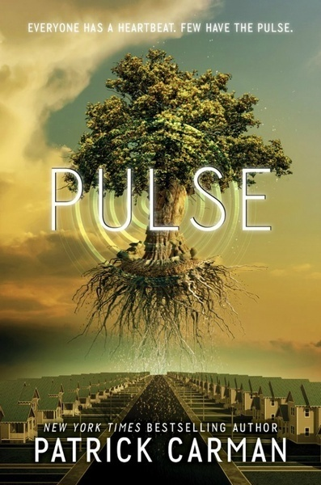
- What kind of book did you pick and why did you pick it?
- What kind of book and feeling where you trying to create?
- What choices of design did you make to create this feeling?
- Tell us about your design, how did you do it?
- Do you have anyting more to add, please do!
